**PART A**

(Part A: TO BE REFFERED BY STUDENTS)

**Experiment No. 08**

**A.1 AIM:**

To apply various effects and animation on a webpage using JQuery.

**A.2 Pre requisite:**

Basic Knowledge of HTML,CSS and JavaScript

**A.3 Outcome:**

After successful completion of this experiment students will be able to:

1. Create interactive webpage using JQuery

**A.4 Theory:**

jQuery is a fast, small, and feature-rich JavaScript library. It makes things like HTML document traversal and manipulation, event handling, animation, and Ajax much simpler with an easy-to-use API that works across a multitude of browsers. With a combination of versatility and extensibility, jQuery has changed the way that millions of people write JavaScript.

jQuery is a lightweight, "write less, do more", JavaScript library. The purpose of jQuery is to make it much easier to use JavaScript on your website. jQuery takes a lot of common tasks that require many lines of JavaScript code to accomplish, and wraps them into methods that you can call with a single line of code. jQuery also simplifies a lot of the complicated things from JavaScript, like AJAX calls and DOM manipulation.

The jQuery library contains the following features:

* HTML/DOM manipulation
* CSS manipulation
* HTML event methods
* Effects and animations
* AJAX
* Utilities

jQuery will run exactly the same in all major browsers.

There are several ways to start using jQuery on your web site. You can:

* Download the jQuery library from jQuery.com
* Include jQuery from a CDN, like Google

**Downloading jQuery :**

There are two versions of jQuery available for downloading:

* Production version - this is for your live website because it has been minified and compressed
* Development version - this is for testing and development (uncompressed and readable code)

Both versions can be downloaded from jQuery.com. The jQuery library is a single JavaScript file, and you reference it with the HTML <script> tag (notice that the <script> tag should be inside the <head> section):

<head>  
<script src="jquery-3.5.1.min.js"></script>  
</head>

If you don't want to download and host jQuery yourself, you can include it from a CDN (Content Delivery Network). Google is an example of someone who host jQuery:

<head>  
<script src="https://ajax.googleapis.com/ajax/libs/jquery/3.5.1/jquery.min.js"></script>  
</head>

One big advantage of using the hosted jQuery from Google is that many users already have downloaded jQuery from Google when visiting another site. As a result, it will be loaded from cache when they visit your site, which leads to faster loading time. Also, most CDN's will make sure that once a user requests a file from it, it will be served from the server closest to them, which also leads to faster loading time.

**jQuery Syntax**

With jQuery you select (query) HTML elements and perform "actions" on them. The jQuery syntax is tailor-made for selecting HTML elements and performing some action on the element(s).

Basic syntax is: *$(selector).action()*

* A $ sign to define/access jQuery
* A (selector) to "query (or find)" HTML elements
* A jQuery action() to be performed on the element(s)

Examples:

$(this).hide() - hides the current element.

$("p").hide() - hides all <p> elements.

$(".test").hide() - hides all elements with class="test".

$("#test").hide() - hides the element with id="test".

**The Document Ready Event**

You might have noticed that all jQuery methods in our examples, are inside a document ready event:

*$(document).ready(function(){*

*// jQuery methods go here...*

*});*

This is to prevent any jQuery code from running before the document is finished loading (is ready).

It is good practice to wait for the document to be fully loaded and ready before working with it. This also allows you to have your JavaScript code before the body of your document, in the head section.

Here are some examples of actions that can fail if methods are run before the document is fully loaded:

* Trying to hide an element that is not created yet
* Trying to get the size of an image that is not loaded yet

**jQuery Selectors**

jQuery selectors allow you to select and manipulate HTML element(s). jQuery selectors are used to "find" (or select) HTML elements based on their name, id, classes, types, attributes, values of attributes and much more. It's based on the existing CSS Selectors, and in addition, it has some own custom selectors. All selectors in jQuery start with the dollar sign and parentheses: $().

Various jQuery selectors are :

* Element Selector
* #id selector
* .class selector
* All selector
* This selector

**jQuery Events**

jQuery is tailor-made to respond to events in an HTML page. All the differentvisitors' actions that a web page can respond to are called events. An event represents the precise moment when something happens.

Examples:

* moving a mouse over an element
* selecting a radio button
* clicking on an element

The term "fires/fired" is often used with events. Example: "The keypress event is fired, the moment you press a key".

Here are some common DOM events:

|  |  |  |  |
| --- | --- | --- | --- |
| **Mouse Events** | **Keyboard Events** | **Form Events** | **Document/Window Events** |
| click | keypress | submit | load |
| dblclick | keydown | change | resize |
| mouseenter | keyup | focus | scroll |
| mouseleave |  | blur | unload |

**jQuery Effects**

Hide, Show, Toggle, Slide, Fade, and Animate

**jQuery Traversing**

jQuery traversing, which means "move through", are used to "find" (or select) HTML elements based on their relation to other elements. Start with one selection and move through that selection until you reach the elements you desire. The image below illustrates an HTML page as a tree (DOM tree). With jQuery traversing, you can easily move up (ancestors), down (descendants) and sideways (siblings) in the tree, starting from the selected (current) element. This movement is called traversing - or moving through - the DOM tree.

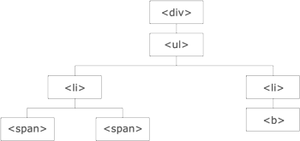

Illustration explained:

* The <div> element is the parent of <ul>, and an ancestor of everything inside of it
* The <ul> element is the parent of both <li> elements, and a child of <div>
* The left <li> element is the parent of <span>, child of <ul> and a descendant of <div>
* The <span> element is a child of the left <li> and a descendant of <ul> and <div>
* The two <li> elements are siblings (they share the same parent)
* The right <li> element is the parent of <b>, child of <ul> and a descendant of <div>
* The <b> element is a child of the right <li> and a descendant of <ul> and <div>

An ancestor is a parent, grandparent, great-grandparent, and so on. A descendant is a child, grandchild, great-grandchild, and so on. Siblings share the same parent.

**A.5 Procedure/Task:**

1. Create a webpage using HTML, CSS and Javascript.

2. Apply various effects and animations to it using JQuery as discussed and practiced in class

3. Prepare the document. Save and close the file and name it as **EXP08_Roll no_Batch no.**

**PART B**

(PART B: TO BE COMPLETED BY STUDENTS)

(Students must submit the soft copy as per following segments within two hours of the practical. The soft copy must be uploaded on the Blackboard or emailed to the concerned lab in charge faculties at the end of the practical in case the there is no Black board access available)

|  |  |
| --- | --- |
| Roll No. : C146 | Name: Manan Gandhi |
| Class : D | Batch : D1 |
| Date of Experiment : 19/09/24 | Date/Time of Submission : |
| Grade : |  |

**B.1 Code:**

*(Paste your Code here)*

<!DOCTYPE *html*>

<html *lang*="en">

<head>

<meta *charset*="UTF-8">

<meta *name*="viewport" *content*="width=device-width, initial-scale=1.0">

<title>Document</title>

<script *src*="jquery-3.7.1.min.js"></script>

<script>

*$*(*document*).*ready*(function () {

*$*("h1").*click*(function () {

*$*(*this*).*hide*();

});

*$*("#double-click").*click*(function () {

*alert*("Double Clicked")

*$*(*this*).*hide*()

})

*$*("#hover").*hover*(function () {

*$*(*this*).*css*('color', 'red')

})

*$*("#hover").*mouseleave*(function () {

*$*(*this*).*css*('color', 'black')

})

});

</script>

</head>

<body>

<h1>Hello!</h1>

<p *id*="double-click">Double Click</p>

<p *id*="hover">Hover to change color</p>

</body>

</html>

**B.2 Output**

*(Take screen shots of the output at run time and paste it here)*

**B.3 Conclusion:**

*(Students must write the conclusion as per the attainment of individual outcome listed above)*

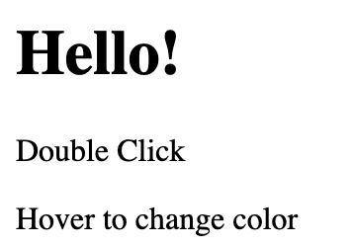

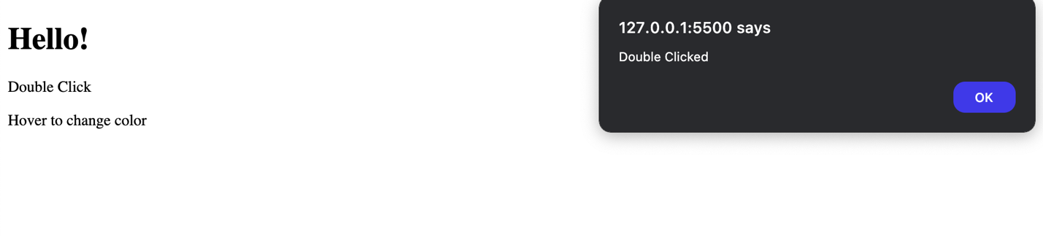

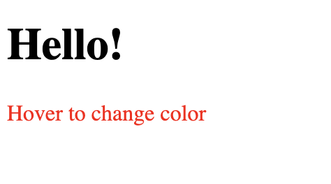

**B.3 Observations and Learning:**

*(Students must write their observations and learnings as per the attainment of individual outcome listed above)*

**B.4 Question of Curiosity**

*(To be answered by student based on the practical performed and learning/observations)*

Q1. Attach a click and double-click event to the <p> element.

For single click append the following paragraph : <p>This is a click Event</p>

For double-click append the following paragraph : <p>This is a double-click Event</p>

Sample Output :

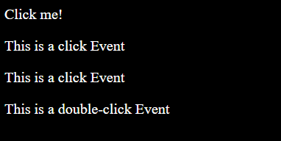

Q2 . Toggle between fading in and fading out different boxes at different speeds.